

COEN 6312
Model Driven Software Engineering
Winter 2016

Deliverable 2
(ONLINE BOOK STORE)

(Team-Singh )

Guneet Singh
Rattandeep Singh
Satinder pal Singh

Table of Contents
1. Textual Description of Online Book Store 5
2. Use Case Model 7
2.1 Use Case Diagram 7
2.2 Use Case Description 8
3. Functional requirements 15
3.1 Account Registration 15
3.2 Account Login 15
3.3 Search Books 15
3.4 Add to Shopping Cart 15
3.5 Delete from shopping cart 15
3.6 Place order 15
3.7 Contact Us 16
3.8 Update Account Information 16
3.9 View Account Purchase History 16
3.10 Account Logout 16
3.11 Invoice and confirmation 16
4. Non-functional requirements: 16
4.1 Usability: 16
4.2 Reliability: 16
4.3 Performance: 16
4.4 Maintainability: 16
4.5 Testability: 17
4.6 Security: 17
5. Tools Used In Deliverable 18
6. Glossary 18
7. References 19

List of Figures
Figure 1: Use Case Model for ONLINE BOOK STORE (Papyrus). 7

List of Tables
Table 1: Description of “Maintenance” Use Case 8
Table 2: Description of “Login” Use Case 9
Table 3: Description of “Manage Profile” Use Case 9
Table 4: Description of “Register” Use Case 10
Table 5: Description of “Search Books” Use Case 10
Table 6: Description of “Perform Book Search” Use Case 11
Table 7: Description of “Place Order” Use Case 11
Table 9: Description of “View Cart Details” Use Case 12
Table 10: Description of “Update Item Quantity” Use Case 12
Table 11: Description of “Update Billing and Shipping Details” Use Case 12
Table 12: Description of “Make Purchase” Use Case 13
Table 13: Description of “Invoice and Confirmation” Use Case 13
Table 14: Description of “Validate Card Payment” Use Case 14
Table 15: Description of “Cancel Order” Use Case. 15

Textual Description of Online Book Store

An “Online Book Store” system is a commercial enterprise that consists of an online bookstore system. This system aims to make all operations automatic for shopping a particular book. The meaning of automation in the software for shopping books online is that users can buy books without going to the physical store, waste time searching for a book and then stand in the queue to make the payment.
The main objective of the project is to design an online bookstore system, which enables the customers to search and buy a book online. As per the survey published in the Investing in the Future of Canadian books - discussion paper July, 2010, it is evident that Canadians are avid readers and they read book for leisure, interest and to improve the quality of life (85% of all readers) and for that they spend at least six hours a week[1].
The focus of our project is to give more facilities with fewer complexities to the readers of Canada who are passionate for reading and are not able to find a book in the nearest physical book store.

Objective:
- An online bookstore System is an application supporting the direct contact with the customers through web site. This System make the life of customers very easy, as they do not need to go to the bookstore physically and look for books.

- A customer can go on the website and search for the desired book by providing the details such as: book name or Author.

- The customer can register itself using a unique ID and password. A single customer can have multiple logins in Books E-Store but all logins must be unique.
- A customer can place multiple orders of books or no order at all. A customer can access the store just to look into the store

- The customer can access the profile after selecting “My account option” to update billing and shipping information or to see the past orders.

- The customer can search for the desired book by entering the book name or the author name or both. The system gives suggestions based on the information added by the customer.

- Once the customer finds the desired book, he/she can add it to the cart. When the book is added to the cart, the customer can continue to search the website for more books if he/she wishes to. If the customer finds another book, then he/she can add it to the cart. So now, both the books selected by the customers would be present in the cart.

- If the customer wants more than one copy of a particular book or if the customer wants to delete the selected book. He/She may do so by checking the cart and increasing/decreasing the number of copies of a book or deleting the book from the selection. The cart shows the total amount for the items present in the cart.

- Once the customer has finalized the books, he/she can move to “proceed to payment” button and enter the credit card details (i.e. if it has not been entered earlier in the profile). Once it is done the card details will be sent to the bank that verifies if the information added is acceptable or if sufficient funds are available. Once this is done an appropriate confirmation message would be shown whether the payment was accept or not and if the payment was accepted then an invoice would be generated and emailed to the customer.

- This system allows customers to buy books online from their home or anywhere from around the country. The customers can choose the exact book they want or search for different genres. The customers can make their payment via credit card.

Use Case Model

2.1 Use Case Diagram

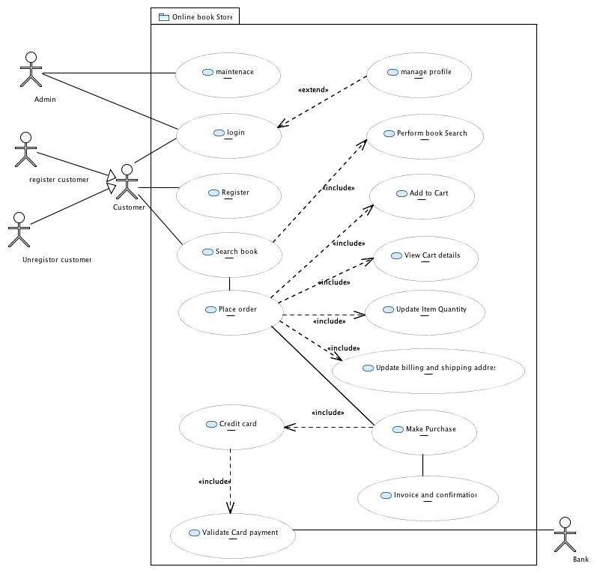
Figure 1: Use Case Model for ONLINE BOOK STORE (Papyrus).

2.2 Use Case Description
A use case model for a software system is the set of all actors, and the set of all use cases, and the relevant relationships among them. A use case model provides view of a system that emphasizes the behavior as it appears to external (or outside) users [2].

Name Maintenance
Short Description | For the maintenance of Online Book store in terms of designing, implementing, testing, upgrading, and maintaining, database as well.
Precondition | Should have access to modify Online Book store.
Post-condition | Online Book store is updated with new features and information.
Error Situation | Not having an access to modify the Online Book store.
System state in the event of an error | Admin team member cannot perform the maintenance operation.
Actors | Admin
Trigger | A team member wants to make changes to the system.
Standard Process | - Team member accesses the web application framework or the database.  - Team member looks for the code to be modified/changed.  - Team member changes the code and tests the new implementation.  - The change is approve for next release.
Alternative Process | No alternative process available

Table 1: Description of “Maintenance” Use Case

Name Login
Short Description | The registered customers access the Online Book store Using username and password.
Precondition | Login credentials should match the customer database.
Post-condition | Registered customer and Admin can access the Online Book store.
Error Situation | Login credentials of the customer are incorrect.
System state in the event of an error | Re-enter credentials and provide help for forgotten credentials.
Actors | Registered customer and Admin
Trigger | Registered customer and Admin enters the right credentials.
Standard Process | - Admin and Customer enters the credentials.  - System checks the database for credentials.  - If credentials match, customer and admin gets an access to Online Book store.
Alternative Process | (3’) The customer and admin will be asked to re-enter the credentials or gets help for forgotten credentials.

Table 2: Description of “Login” Use Case

Name Manage Profile
Short Description | It helps Users to manage their profile in the system. For example, if User want to change their credentials then he/she can easily update their particulars in the system.
Precondition | User should register himself/herself in the system.
Post-condition | User’s credentials should be updated successfully.
Error situation | (1)The user is not able to login into system.  (2) The user has entered wrong credentials.
System state in the event of an error | Display a message to enter correct credentials.
Actors | User
Trigger | User proceeds to manage profile page after login.
Standard Process | - User logged in the system successfully.  - User click on manage profile link to land on the page.  - User updates his/her information successfully.
Alternative Process | NIL

Table 3: Description of “Manage Profile” Use Case

Name Register
Short Description | Enables a user to get registered and have an account in the Online Book store.
Precondition | No precondition.
Post-condition | A non-registered customer will be registered.
Error situation | Customer enters improper data.
System state in the event of an error | Asks the customer to re-enter the data.
Actors | Non-registered customer
Trigger | Customer decides to register.
Standard Process | (1) Customer enters the details like username, email, and password.  (2) System checks if the details are unique and correct.  (3) System inserts the new customer’s detail to the existing customer database.
Alternative Process | (3’) If the details are incorrect, an error message is displayed and the user is asked to re-enter the details.

Table 4: Description of “Register” Use Case

Name Search Books
Short Description | Customer looks for the required book.
Precondition | Customer has login into system (optional).
Post-condition | Customer finds or does not find the searched book.
Error Situation | Customer misspells the book/author name.
System state in the event of an error | Displays unavailability of the book to the customer and show some suggestions.
Actors | Customer
Trigger | Customer Intends to search the required book.
Standard Process | - Customer searches for a particular book by book name or author name.  - Checks availability of the searched book.  - Displays information of the book.
Alternative Process | No alternative process available.

Table 5: Description of “Search Books” Use Case

Name Perform book search
Short Description | Customer looks for the required book.
Precondition | Customer has login into system (optional).
Post-condition | Customer finds or does not find the searched book.
Error Situation | Customer misspells the book/author name.
System state in the event of an error | Displays unavailability of the book to the customer and show some suggestions.
Actors | Customer
Standard Process | - Customer searches for a particular book by name of book or author name.  - Checks availability of the searched book.  - Displays information of the book.
Alternative Process | No alternative process available.

Table 6: Description of “Perform Book Search” Use Case

Name Place order
Short Description | Customer chooses the book; he/she wish to buy.
Precondition | Customer has logged into BOOKS E-Store and searched for the book.
Post-condition | Books selected and added to shopping cart.
Error Situation | The requested book is unavailable now It is better to say “at the time of access”.
System state in the event of an error | The customer cannot select the book.
Actors | Registered customer
Trigger | Customer clicks the “Add to cart” button.
Standard Process | (1) The customer logins into the system.  (2) The customer searches for the book.  (3) The customer selects the book.

Table 7: Description of “Place Order” Use Case

Name Add to cart
Short Description | Customer adds the selected book to the cart.
Precondition | Customer has login into system (optional) and selected the book.
Post-condition | Customer adds the book to the cart.
Actors | Customer
Trigger | Customer clicks the “Add to cart” button.
Standard Process | - Customer searches for the desired book.  - Customer selects the book.  - Customer adds the book to the cart.
Alternative Process | No alternative process available.

Table 8: Description of “Add to Cart” Use Case

Name View Cart details
Short Description | Customer looks at the shopping cart
Precondition | Customer has added book/s to the cart.
Post-condition | Customer gets the list of books in the cart.
Actors | Customer
Trigger | The customer clicks on “View cart” button.
Standard Process | - Customer clicks on Cart.  - Checks the books present in the cart.
Alternative Process | No alternative process available.

Table 9: Description of “View Cart Details” Use Case

Name Update Item quantity
Short Description | Customer edits the quantity.
Precondition | A book is already present in the cart.
Post-condition | Customer edits the quantity of the book.
Actors | Customer
Trigger | The customer updates the quantity of a particular book. The customer may increase or decrease the number of copies of a particular book.
Standard Process | - The Customer selects the book he/she wants to update the quantity of Items.  - Customer may delete the selected book.
Alternative Process | No alternative process available.

Table 10: Description of “Update Item Quantity” Use Case

Name Update Billing and Shipping details
Short Description | Customer updates the billing and shipping details
Precondition
Post-condition | Updated billing and shipping information.
Actors | Customer
Trigger | The customer updates the billing details (i.e. credit card details and the bank) and the shipping details.
Standard Process | - Customer logs into the system.  - Customer enters the billing information.  - Customer enters the shipping details.
Alternative Process | No alternative process available.

Table 11: Description of “Update Billing and Shipping Details” Use Case

Name Make Purchase
Short Description | This use case describes that the system will be able to generate the total amount for the books selected by the customer.
Precondition | Customer must have selected a minimum of one book and it should be added in the cart.
Post-condition | The system generates the total amount and the customer fills in the credit card details for payment.
Actors | System
Trigger | The customer clicks “Proceed to payment” button.
Standard Process | - The system retrieves the customer information.  - The system will check if a borrower is register in the system.  - The system adds all the fees that appear in the shopping cart to the customer’s account.  - The system updates the borrower record with the newly calculated fees.  - The system updates the database.  - The system notifies via e-mail the borrower about the fees.
Alternative Process | No alternative process available.

Table 12: Description of “Make Purchase” Use Case

Name Invoice and Confirmation
Short Description | This use case describes that the system generates receipt/invoice for the customer
Precondition | The customer pays for the items present in the shopping cart.
Post-condition | The system generates the invoice for the paid items.
Actors | Customer
Trigger | Payment accepted.
Standard Process | - System generated the receipt for the customer.  - System updates the customer’s record with the generated receipt/invoice.
Alternative Process | No alternative process available.

Table 13: Description of “Invoice and Confirmation” Use Case

Name Validate card Payment
Short Description | This use case describes that the bank validates the card payment made by the customer.
Precondition | The customer makes the payment via credit cards
Post-condition | Success end condition:  - Customer attempts to make the payment for the book(s).  - Customer pays via credit card.  - Bank validates the card.  - Bank accepts the payment  - System updates the database  Failure end condition:  - Customer not providing valid card information or insufficient funds.  - Bank unable to validate card information  - System notify Customer with an error message
Actors | Bank
Trigger | The customer has clicked on “Proceed to payment” button after entering the necessary card and shipping details.
Standard Process | - Customer retrieves the payment total  - Customer pay the total amount through card  - Bank validates the card  - Bank deducts amount from the card  - System updates the database  - System generates receipt  - System notifies Customer the payment information via email
Alternative Process | No alternative process available.

Table 14: Description of “Validate Card Payment” Use Case

Name Cancel Order
Short Description | The customer wants to cancel the order.
Precondition | Payment is approved for the order but the order is yet to be shipped for delivery.
Post-condition | Order is cancelled and refund has been initiated through concerned bank.
Error Situation | The order is already in transit.
System state in the event of an error | The customer cannot cancel the order once it is shipped.
Actors | Customer
Standard Process | - The customer logs in and views all the orders.  - The customer selects a particular order.  - The customer chooses to cancel the order.  - The customer provides a reason of cancelling the order. (Optional)
Alternative Process | No alternate process available.

Table 15: Description of “Cancel Order” Use Case.

Functional requirements

Function requirements are from the systems point of view that is how the system is going to achieve the different objectives [3].

3.1 Account Registration
The system shall allow a non-registered user to create a secure account.

3.2 Account Login
The system shall allow the registered user to log into their account after verifying password and username.

3.3 Search Books
The system shall allow the user to search for books by title and author. The result will include a picture of the front cover, along with the title, author and price.

3.4 Add to Shopping Cart
The system shall allow a registered or an unregistered user to temporarily save books that are being considered for purchase into a list associated with their account. When viewing the shopping cart list, it displays the total price for the books in the cart.

3.5 Delete from shopping cart
The system shall allow a registered or unregistered user to remove any unwanted book from their shopping cart. The system shall provide the user a way to select one of the books in his/her cart. After the user has indicated the particular book to be deleted from the shopping cart, the stored list representing the shopping cart should be updated to show only the books remaining in the cart.

3.6 Place order
Once the customer has finalized the books he/she want to buy, they shall proceed to checkout, and the system shall place the order and send the credit card details to the bank. Once the funds are verified by the bank the system shall provide the necessary information to the customer i.e. if the purchase is successful or not.

3.7 Contact Us
The system shall allow a user to view various methods of contacting the store. The system shall display the telephone number, email address and hours of operation.

3.8 Update Account Information
The system shall allow the user to update the information in their account. The user shall be allowed to view and change their name, mailing address, billing address, credit card information. The user shall be allowed to change the password by entering the old one once and the new one twice.

3.9 View Account Purchase History
The system shall allow a registered user to view purchases made with their account within the last two years. The system shall display the title of the book, price and quantity of each book purchased in a given order.

3.10 Account Logout
The system shall allow the registered and logged-in user to exit his/her account, so that accesses to operations requiring a user to be logged in are now disabled.

3.11 Invoice and confirmation
Invoice is generated once the payment is successful and verified by the bank.

Non-functional requirements:

To meet the desired quality the system should adhere to the following nonfunctional requirements. There are requirements that are not functional in nature. Specifically, the system must work within these constraints[4].

4.1 Usability:
The system should be easier to learn, operate and shall assist the user.

4.2 Reliability:
The system should handle expected and non-expected errors in a way that prevents loss in information.

4.3 Performance:
The system shall accommodate high number of books and users without any fault.

4.4 Maintainability:
It represents the ease with which the system can be modified i.e. to improve or make changes to it.

4.5 Testability:
It is the degree to which a software supports testing in a given context.

4.6 Security:
System will use secured DB. System will have different types of users and every user have access constraints. After entering the username and password, the user can access his profile.

Tools Used In Deliverable

Besides using regular word processing applications, we have used the following tools for communication, document sharing and producing diagrams- google drive, WhatsApp, Gmail, GIT HUB, Microsoft Word and Papyrus.

Glossary

C
Customer
A customer is the recipient of a good, service, product, or idea, obtained from a seller, vendor, or supplier for a monetary or other valuable consideration.

E

Enterprise System
This system is responsible for designing, analyzing and testing of the software.

O
Online Store
It is the place where people can buy merchandize, at anytime, anywhere.

R
Registered Customers: They are customers who have an account in the system for accessing the web with every feature of the system.

S
Shopping Cart
A shopping cart is a cart supplied by a shop for use by customers.

U
Unregistered Customers: They are customers who have not account in the system but can access the web but with lesser features.

References

- “Canadian Heritage” 2008 Canadian Books Readership Study, Decima Research - http://www.pch.gc.ca/DAMAssetPub/DAM-livres-books/STAGING/texte-text/discuss-paper_1279033118003_eng.pdf?WT.contentAuthority=12.2.1
- https://en.wikipedia.org/wiki/Use_Case_Diagram
- https://en.wikipedia.org/wiki/Functional_requirement
- https://en.wikipedia.org/wiki/Non-functional_requirement

